Electroanalytical methods are a class of techniques in analytical chemistry, which study an analyte by measuring the potential (volts) and/or current (amperes) in an electrochemical cell containing the analyte.
The three main categories are potentiometry (the difference in electrode potentials is measured), coulometry (the cell's current is measured over time), and voltammetry (the cell's current is measured while actively altering the cell's potential).
Electroanalytical chemistry encompasses a group of quantitative analytical methods that are based upon the electrical properties of a solution of the analyte when it is made part of an electrochemical cell. Electroanalytical methods have certain general advantages over other types of procedures
– often specific for a particular oxidation state of an element.
– Instrumentation is relatively inexpensive.
– Provide information about activities rather than concentrations of chemical species.
Potentiometry: measure the potential of electrochemical cells without drawing substantial current. Examples: pH measurements, ion-selective electrodes, titrations.
Coulometry: measures the electricity required to drive an electrolytic oxid. /red. to completion Examples: titrations, “chloridometers” (AgCl).
Voltammetry: measures current as a function of applied potential under conditions that keep a working electrode polarized - Examples: cyclic voltammetry, many biosensors.

Potentiometry
Potential is measured under the conditions of no current flow. The measured potential is proportional to the concentration of some component of the analyte. The potential that develops in the electrochemical cell is the result of the free energy change that would occur if the chemical phenomena were to proceed until the equilibrium condition has been satisfied.
${∆G}_{rxn}= -nFE_{rxn}$
Combining two half-cells (two half-redox reactions) and measuring the potential difference between them that gives Ecell. If the potential of one half-cell (one- half reaction) is held constant, then the potential of the other half (half-cell or half reaction) will be known and consequently the concentration of the species on this side can be measured.
Electrode Potentials:
Standard potential for cell, E⁰_{cell}, follows Nernst Equation: E⁰_{cell} = (RT/nF) lnK, R is gas law constant, T is temperature, K is equilibrium constant, F is the Faraday, and n is number of equivalents of electricity. Electrode potential is sum of two half-reactions. It cannot determine potential of a single electrode, measure differences in potential.
To perform potentiometry, the following is needed:

- Reference Electrode: chosen so that its potential is independent of solution composition.
- Indicator Electrode (test electrode): potential responds to activity of species of interest i.e. analyte.
- Potential Measuring Device
Potentiometry passively measures the potential of a solution between two electrodes, affecting the solution very little in the process. One electrode is called the reference electrode and has a constant potential, while the other one is an indicator electrode whose potential changes with the composition of the sample. Therefore, the difference of potential between the two electrodes gives an assessment of the composition of the sample. In fact, since potentiometric measurement is a non-destructive measurement, assuming that the electrode is in equilibrium with the solution we are measuring the potential of the solution. Potentiometry usually uses indicator electrodes made selectively sensitive to the ion of interest, such as fluoride in fluoride selective electrodes. The time that takes the electrode to establish equilibrium with the solution will affect the sensitivity or accuracy of the measurement. In aquatic environments, platinum is often used due to its high electron transfer kinetics, although an electrode made from several metals can be used in order to enhance to electron transfer kinetics. The most common potentiometric electrode is by far the glass-membrane electrode used in a pH meter.

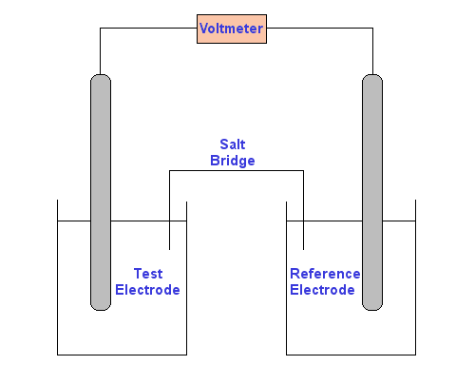

The Nernst equation
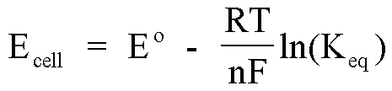
Example
You wish to find the concentration of Ag⁺ in a silver nitrate solution. Your reference electrode consists of silver metal in a known 0.1 M silver nitrate solution. Your test electrode is silver metal in the silver nitrate solution you wish to find the concentration of.
Since no current flows, the cell is at equilibrium:
Ag⁺ ⇌ Ag
The solutions are linked by a 0.1 M potassium nitrate salt bridge. The metal electrodes are linked by a voltmeter.
There will be a potential difference between the two solutions resulting from the different concentrations of silver ions in contact with the silver electrodes.
The potential you measure on the voltmeter, E_{cell} is related to the reference electrode potential and test electrode potential as follows:
E_{cell} = E_{reference} - E_{test} (Equation 1)
Now, E_{reference} and E_{test} can both be expanded using the Nernst Equation:
E_{reference} = E°_{Ag/Ag+} - RTlnK_{eq}/nF
Therefore, at a temperature of 298 K:
E_{reference} = E°_{Ag/Ag+} - 0.059log₁₀(1/[Ag⁺_{reference}]) (Equation 2)
Similarly:
E_{test} = E°_{Ag/Ag+} - 0.059log₁₀(1/[Ag⁺_{test}]) (Equation 3)
Now we can substitute Equation 2 and Equation 3 into Equation 1. We can also assume [Ag⁺_{reference}] is a constant. So, after rearranging, we get:
[Ag⁺_{test}] = 10^{- [(E}_{cell} + 0.059)/0.059] (Equation 4)
The potential reading from the voltmeter is E_{cell}. All you need to do now is to enter your reading from the voltmeter into Equation 4 and calculate the concentration of silver ions in the test solution.
Voltammetry
In voltammetry, information about an analyte is obtained by measuring the current as the potential is varied. The analytical data for a voltammetry experiment comes in the form of a voltammagram which plots the current produced by the analyte versus the potential of the working electrode.
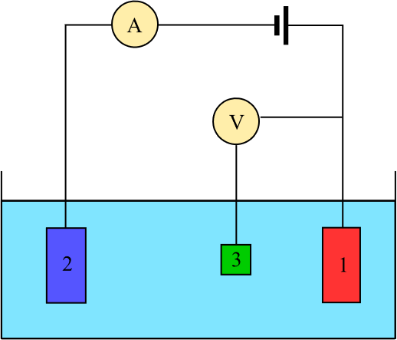
Three-electrode setup: (1) working electrode; (2) counter electrode; (3) reference electrode
Voltammetry is the study of current as a function of applied potential. These curves I = f(E) are called voltammograms. The potential is varied arbitrarily either step by step or continuously, and the actual current value is measured as the dependent variable. The shape of the curves depends on the speed of potential variation (nature of driving force) and on whether the solution is stirred or quiescent (mass transfer). Most experiments control the potential (volts) of an electrode in contact with the analyte while measuring the resulting current (amperes). To conduct such an experiment one requires at least two electrodes. The working electrode, which makes contact with the analyte, must apply the desired potential in a controlled way and facilitate the transfer of charge to and from the analyte. A second electrode acts as the other half of the cell. This second electrode must have a known potential with which to gauge the potential of the working electrode, furthermore it must balance the charge added or removed by the working electrode. Actually, it is extremely difficult for an electrode to maintain a constant potential while passing current to counter redox events at the working electrode. To solve this problem, the roles of supplying electrons and providing a reference potential are divided between two separate electrodes. The reference electrode is a half cell with a known reduction potential. Its only role is to act as reference in measuring and controlling the working electrode's potential and at no point does it pass any current. The auxiliary electrode passes all the current needed to balance the current observed at the working electrode.
Voltammetry refers to electrochemical methods in which a specific voltage profile is applied to a working electrode as a function of time and the current produced by the system is measured. This is commonly done with an instrument called a potentiostat, which for these measurements is capable of applying variable potentials to the working electrode relative to a reference electrode (like Ag/AgCl) while measuring the current that flows as a result of the electrode reaction. Depending on the particular method, it is possible to apply reducing and/or oxidizing potentials. When a reduction occurs, the current is called a cathodic current. When an oxidation occurs, the current is called an anodic current. Different voltammetric methods involve different voltage profiles. Voltammetric methods are among some of the most common electrochemical methods in use today. There are a variety of voltammetric methods. Voltammetric methods typically involve the use of microelectrodes that frequently have areas on the order of 0.3-10 cm². Originally it was common to use mercury electrodes often as a hanging mercury drop (HMDE) or as drops through a glass capillary (DME) for voltammetric methods. Mercury had several desirable properties in electrode applications. One advantage of mercury is that it has a high overvoltage toward the reduction of H⁺ so it can be used at high reducing potentials in water without leading to the electrochemical splitting of water into hydrogen and oxygen gas. A second advantage of mercury electrodes is that metals dissolve in mercury by forming amalgams, which improves the measurement of low concentrations of analytes. A concern with electrodes is that mercury can become fouled or the surface of a solid electrode can become poisoned, which significantly alters their properties. This can occur if species in the matrix adsorb to the surface of the electrode. Solid electrodes usually are put through a prescribed polishing procedure before used for measurement purposes, while mercury drops can easily be replaced through a glass capillary.
The use of mercury electrodes has fallen into disfavour today because of the toxicity of the metal and the difficulty of controlling spills of the material when used in electrode applications. Other possible electrodes for use in voltammetric methods include carbon paste, glassy carbon, platinum and gold. In addition, with a glassy carbon electrode it is possible to create a thin film of mercury on the electrode by reducing Hg²⁺. This provides the advantages of mercury electrodes described earlier without the necessity for using large quantities of mercury.
Voltammetry includes various types—linear sweep, cyclic, square wave, stripping, alternating current (AC), pulse, steady-state microelectrode, and hydrodynamic voltammetry—depending on a mode of the potential control. The most frequently used technique is cyclic voltammetry (CV) on a time scale of seconds. In contrast, currently used voltammetry at time as short as milliseconds is AC voltammetry.

